
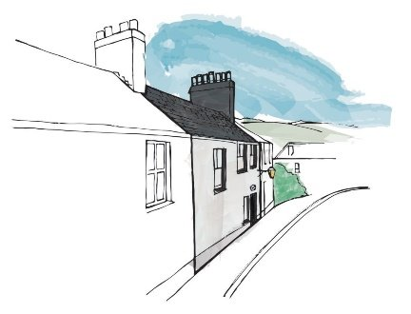

The Charles Causley Trust

Section 1: Individual Trustee Skills Audit
Please rate your level of expertise against each item using the scale below. Part A covers the core governance and organisational skills any charity board needs. Part B covers skills and knowledge specific to the Trust’s work.
Level of expertise:
1 = highly experienced 2 = proficient 3 = some experience 4 = no experience
Name

Skill, expertise or knowledge | 1 | 2 | 3 | 4 | Comments
Part A — Core governance and organisational skills
Governance and board
Administration
Board / committee experience
Charity / voluntary organisation governance
Voluntary sector experience
Facilitating and chairing meetings
Conflict resolution
Leadership and people
Leadership
People management
Team development
HR / training
Relationship management
Listening
Influencing
Finance and Fundraising
Finance
Fundraising (philanthropic)
Fundraising (grant organisations)
Income generation (culture & heritage)
Operations, digital and communications
IT / systems
Digital – social media and website
Marketing
PR / communications
Project management
Change management
Other professional skills
Legal
Property
Campaigning
Service user / beneficiary of the organisation
Part B — Skills and knowledge specific to the Charles Causley Trust
Literature, poetry and the arts
Writing for and with children and young people
Literary & poetry publishing knowledge
Charles Causley’s work
International literary networks and / or translation
Heritage, archive and Cyprus Well
Historic / listed building conservation and maintenance
Property lettings, holiday accommodation and hosting residents
Programmes and delivery
Festival and live-events production
Education partnerships and working with schools
Audience development for arts and literary audiences
Income and sustainability (arts and heritage)
Arts and heritage funding (Arts Council England, National Lottery Heritage Fund)
Trust and grant bid writing for arts and literature funders
Children, young people and safeguarding
Safeguarding children and young people (including DSL-level expertise)
Youth engagement and co-production with young people
Place, community and partnerships
Knowledge of the Cornish cultural sector and its networks
Local roots and relationships in Launceston and the surrounding community
Knowledge, networks and connections with universities and heritage/arts research
Rural and regional arts development
Other — specialist experience or qualification relevant to the Trust

Section 2: Further information for New Trustee Applications

Motivation
Do you have a particular interest in, or reasons for, being / wanting to be a trustee of the Charles Causley Trust?

Diversity
A diverse board is better able to reflect and support the delivery of the Trust’s mission and to widen access to literature and poetry. Do you have a particular lived experience, social or family background, community connection or interest — for example as a writer, an educator, a young person, or a member of the communities the Trust serves — that would help us support the Trust’s goals?

Areas of work
Are there any areas of the Trust’s work you have a particular interest in and / or would like to become more involved in?

