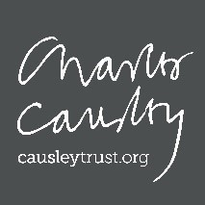
Booking form - Causley Trust Winter Warmer Poetry Retreat
3rd – 5th February 2023

Please fill out our form below and return it by email to info@causleytrust.org.
Name
Home address
Email address
Contact phone number
Please tell us of any dietary requirements (please state allergies, vegetarian or vegan requirements)
Please tell us of any accessibility requirements
Package type (type ‘X’ beside the options to indicate) | Day Residential
Do you require an additional night’s accommodation for a cost of £125?

Please ensure that you send us your 50% deposit at the same time that you send us this booking form. The final balance for your place must be paid by Monday 16th January 2023.

Monitoring information
As part of the support that we receive from the Arts Council, which enables us to run these programmes, we are required to better understand are audiences. It would be really helpful as we report back to the Arts Council, if you could fill in the details below. If you prefer not to do this, please feel free to leave this section blank. If you would rather submit this information in a different format, please get in touch with us.
Prefer not to say (please mark X to indicate)
Age
Ethnicity
Identifies as deaf and/or disabled
Identifies as LGBTQ+
Sexual orientation
Sex registered at birth
Gender identity
Neurodivergent

