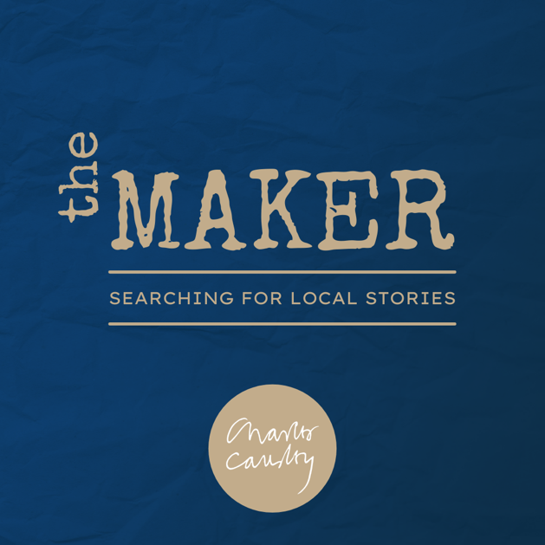

The Maker
The Charles Causley Trust Literary Blog

THEME: “CHOICE”

What we’re looking for:

- Poetry- limit of 50 lines
- Creative non-fiction- limit of 2,000 words
- Short stories- limit of 2,000 words

Are you an undergraduate or postgraduate student? Do you have a passion for creative writing? Then we might have just the online writing platform for you!
We are on the hunt for our next month of creative and critical pieces to publish on The Charles Causley Trust’s new literary blog, The Maker. November’s theme is “CHOICE,” inspired by the theme of this year’s National Poetry Day. We encourage our growing literary community to take this opportunity to submit creative pieces under any theme, no matter how niche, for what we hope to be an incredibly interesting, explorative and varied week of publications.
If you are looking to raise the profile of your work, then this could be your chance to shine. Not only could your writing be seen by the Trust’s existing readership and festival attendees, as well as the Trusts highly engaged community of writers and artists, you could also be part of its expanding pool of younger contributors.
This is a chance to showcase the work of talented students on the Charles Causley Trust’s website, so if you think you have something (or want to pen a new piece) tackling November’s theme in a new and interesting way, we’d love to hear from you.

Deadline for submissions: 16th of November 2021
Email all submissions, along with a brief paragraph letting us know a bit about you, to themaker@causleytrust.org by this date. Please also include a short bio about who you are and where you study, as well as a bit of information about the piece we are about to read.

If you are successful, we’ll be in touch to let you know when you can expect to see your work go live and to discuss any edits or developments, though these will not be extensive. We’re looking to foster connections with local writers and all authors we hear from will be considered for later publications.

We look forward to hearing from you!
Editors,
The Maker
The Charles Causley Trust

If you are interested in volunteering for the Trust, please feel free to get in touch via email at info@causleytrust.org

