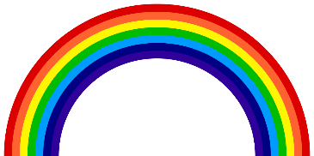
The Things I See in Colour
By William Irish

When I see the blue in the sky,
I see me the blue in a rapid river, sprinting down its track.
When I see the blue in a river,
I see the blue in the flowers, as pretty as a picture.

When I see the yellow in the sand,
I see the yellow in a new born chick, ready to start its story.
When I see the yellow in a new born chick,
I see the yellow in the scorching sun, watching us from above.

When I see the black in negativity,
I see the black in pollution, an invisible enemy.
When I see the black in pollution,
I see the black of night, as dark as ever.

When I see the green in the pastures,
I see the green in nature, the lungs of our planet.
When I see the green in nature,
I see the green in vegetables, keeping us healthy.

When I see the red in a rainbow,
I see the red in a face of embarrassment.
When I see the red in a face of embarrassment,
I see the red in a romantic rose, a reminder of strength and hope.

